INTRODUCTION
  - Project overview
ComicCraft – AI Comic Creator Using Gemini Models is an AI-powered web application that automates the creation of comic stories and illustrations based on user-provided prompts. The application integrates Google's Gemini models and Stable Diffusion to generate personalized comic books with structured storylines, character dialogues, and illustrations.
Users can provide inputs such as the story prompt, character name, setting, narrative tone, and preferred art style. Based on these inputs, Gemini Flash generates a structured five-panel comic outline, while Gemini Pro generates detailed narration and character dialogues. Stable Diffusion is used to create corresponding illustrations for each panel.
The application is developed using FastAPI for backend operations and HTML, CSS, and Jinja2 for the frontend. It provides an interactive interface where users can generate, preview, and customize their comics. The completed comic can also be downloaded in PDF format, containing both illustrations and narrative text.
ComicCraft combines AI-based storytelling, image generation, and document export into a single platform, making comic creation accessible to users without professional writing or drawing skills.
1.2 Purpose
The primary purpose of ComicCraft is to simplify and automate the comic creation process using Generative Artificial Intelligence. It aims to transform user-provided ideas into complete comic stories with illustrations, reducing the time and effort required for manual story writing and image creation.
The project provides a platform for users to create personalized comics by specifying their preferred characters, settings, story tones, and art styles. By integrating Gemini models for story generation and Stable Diffusion for image creation, the application offers an automated approach to producing visually engaging comics.
The system also aims to provide a simple and interactive user interface, allowing users to generate, preview, and download their comics in PDF format. Ultimately, ComicCraft makes comic creation more accessible to beginners, students, and creative enthusiasts, regardless of their artistic or storytelling experience.

IDEATION PAHSE
2.1 Problem Statement – ComicCraft
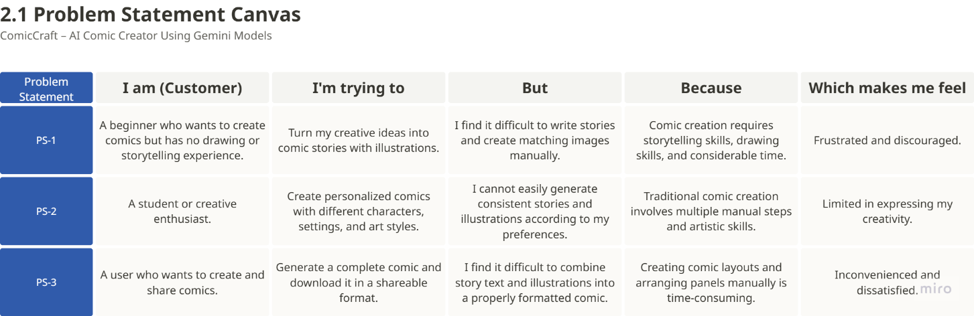

2.2 Empathy Map Template
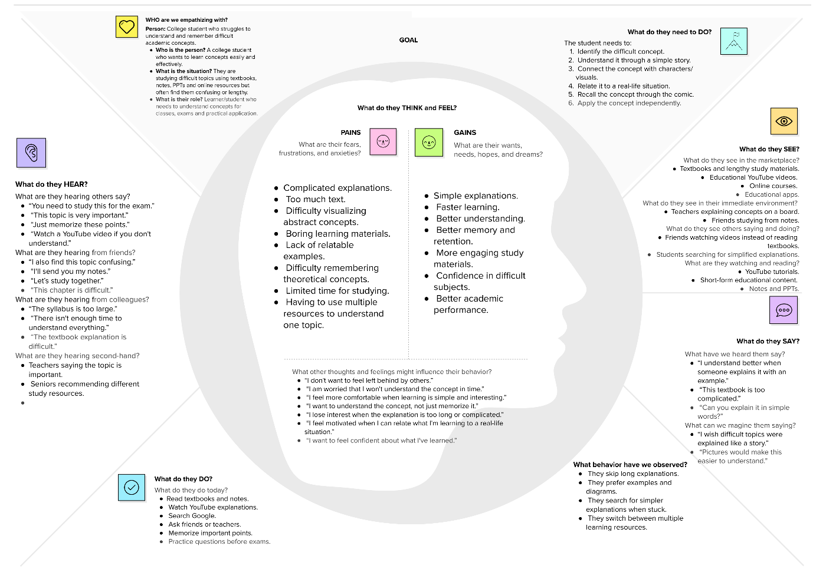

2.3 Brain Storming Template
Step-1: Team Gathering, Collaboration and Select the Problem Statement
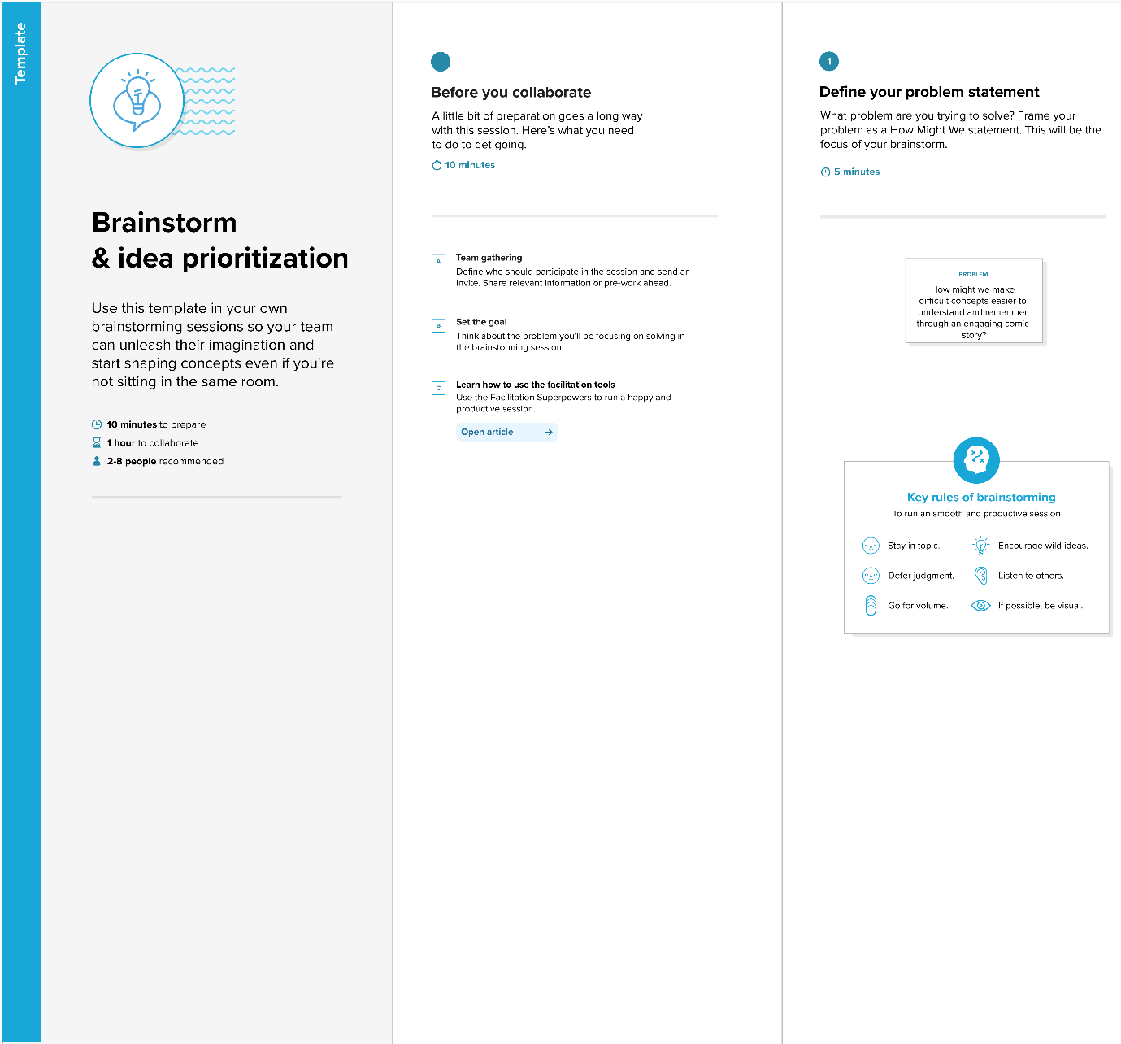

Step-2: Brainstorm, Idea Listing and Grouping
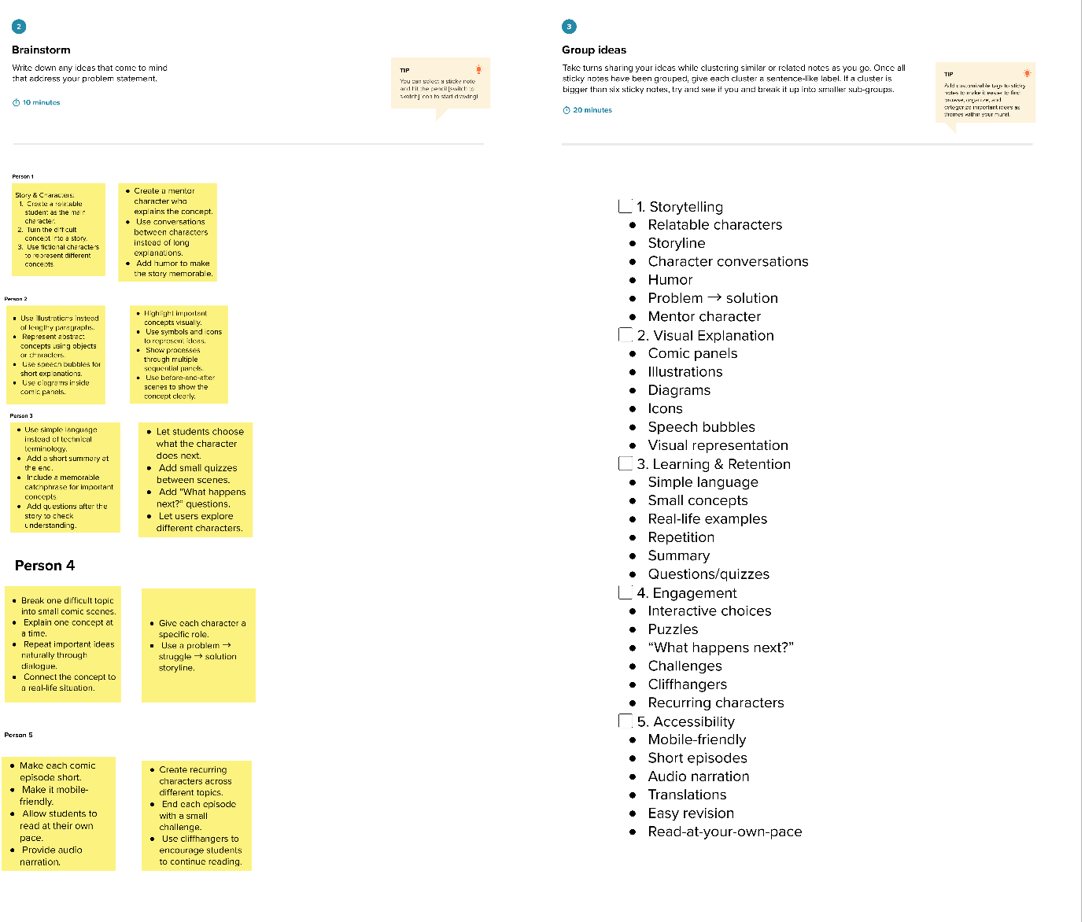
Step-3: Idea Prioritization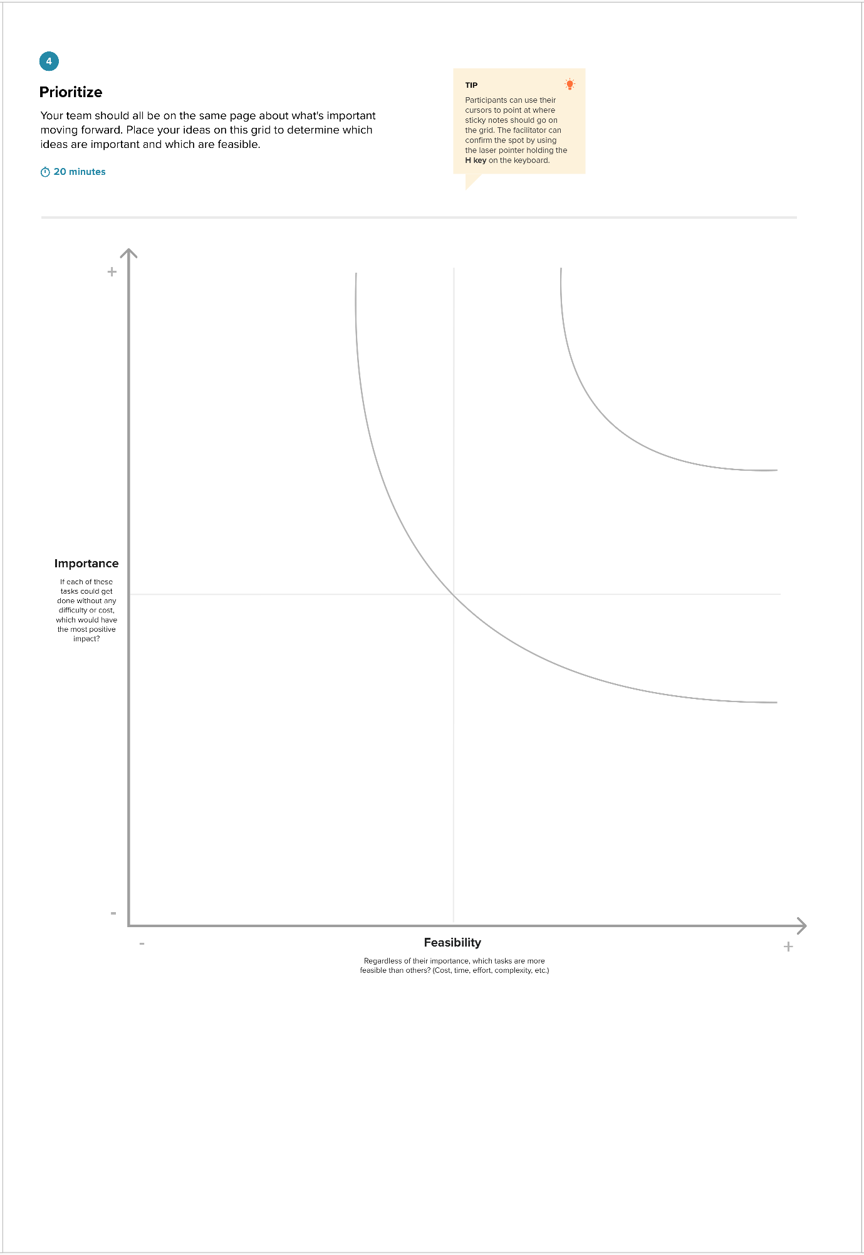

REQUIREMENT ANALYSIS
3.1 Customer journey map
C O M I C C R A F T ▶  AI comic story creation | Based on the ComicCraft project description and its three usage scenarios. Moments and ideas beyond the description are team assumptions to validate with users.
  SCENARIO
  Entering a story idea, generating, previewing and downloading an AI-made comic

 | 1 Entice  How does someone initially become aware of this process? | 2 Enter  What do people experience as they begin the process? | 3 Engage  In the core moments in the process, what happens? | 4 Exit  What do people typically experience as the process finishes? | 5 Extend  What happens after the experience is over?
Steps  What does the person typically experience? | Have a comic idea User wants to turn a story idea into a comic without drawing skills.  Open ComicCraft User opens the web app in a browser (home page).  See the input form Form asks for story prompt, character name, setting, tone and art style. | Write the story prompt e.g. "A brave fox exploring an enchanted forest".  Name the hero and setting e.g. a fox called Rusty in a forest, school or city.  Choose tone and art style Tone: dramatic or funny. Style: anime, comic book, realistic.  Submit the form Data goes to the FastAPI backend through a POST request. | Outline created Gemini Flash builds a 5-panel outline: number, title, scene and image prompt.  Story written Gemini Pro adds narration and character dialogue to every panel.  Images drawn Stable Diffusion makes a comic-style image per panel, saved in static/panels.  Comic preview layout_builder.py joins each image with its text and the preview page shows it. | Review the preview User reads each panel and checks the images.  Download the PDF exporters.py compiles images and narration into a PDF with FPDF, with a timestamped name.  Export success page User is redirected to export_success.html confirming the export. | Try a new tone or style e.g. funny tone and comic book style. The whole pipeline runs again.  Share or print User saves, prints or shares the PDF comic.  Start a new story User returns to the form with a fresh idea.
Interactions  What interactions do they have at each step along the way?  ▪ People: who do they see or talk to?  ▪ Places: where are they?  ▪ Things: what digital touchpoints would they use? | Web browser on phone or desktop.  index.html input form built with HTML, CSS and Jinja2.  /docs page API testing page, mainly for developers. | index.html form text boxes and choices for the five inputs.  Submit button sends the request.  FastAPI backend receives form data or a JSON API call (main.py, routes.py). | Gemini Flash generate_outline() in gemini_flash.py.  Gemini Pro generate_story() in gemini_pro.py.  Stable Diffusion (Diffusers) generate_image() in image_generator.py.  comic_preview.html preview page in the browser. | comic_preview.html preview and download option.  exporters.py (FPDF) save_pdf() writes the PDF to static/exports.  export_success.html confirmation page.  PDF viewer on the user's device. | index.html form used again for the next comic.  Saved PDF stored on the user's device.  Print, email or chat apps outside the app, used for sharing.  API endpoints for developers who call the service.
Goals & motivations  At each step, what is a person's primary goal or motivation? ("Help me..." or "Help me avoid...") | Help me turn my idea into a comic without drawing.  Help me understand what to enter. | Help me describe my story clearly.  Help me personalise the hero and world.  Help me pick the right mood and look. | Help me get a story that fits my idea.  Help me see every scene drawn in my chosen style.  Help me see the full comic quickly. | Help me decide if I'm happy with this comic.  Help me save my comic in a format I can keep.  Help me feel sure the download worked. | Help me refine the mood and look until it matches my vision.  Help me share what I made.  Help me start another comic.

3.2 Solution Requirements
Functional Requirements:
FR No. | Functional Requirement (Epic) | Sub Requirement (Story / Sub-Task)
FR-1 | User Input Management | Enter comic story prompt
 |  | Enter main character name
 |  | Select story setting
 |  | Select story tone
 |  | Select preferred art style
FR-2 | AI Comic Story Generation | Generate structured panel-by-panel comic outline
 |  | Generate comic narration
 |  | Generate character dialogues
 |  | Generate scene descriptions
FR-3 | AI Image Generation | Generate comic-style illustrations for each panel
 |  | Generate images based on AI-generated image prompts
 |  | Display generated images along with the corresponding panels
FR-4 | Comic Preview and Export | Display generated comic panel-by-panel
 |  | Display panel title, image, scene description, caption, and narration
 |  | Generate a complete PDF containing comic images and text
 |  | Allow users to download the generated comic as a PDF
 |  | Display export-success confirmation

Non-Functional Requirements:
NFR No. | Non-Functional Requirement | Description
NFR-1 | Usability | The system shall provide a simple, interactive, and user-friendly interface that allows users to create comics without requiring technical or artistic expertise.
NFR-2 | Security | The system shall protect sensitive API keys and configuration data using environment variables and should validate user inputs before processing them.
NFR-3 | Reliability | The system shall handle AI-generation and processing errors gracefully and provide appropriate responses when comic generation or export fails.
NFR-4 | Performance | The system shall efficiently process user prompts and generate comic outlines, narration, illustrations, and PDF output within a reasonable response time.
NFR-5 | Availability | The application shall be accessible whenever the FastAPI server is running and shall provide both the web interface and API endpoints for comic generation.
NFR-6 | Scalability | The system architecture shall allow future expansion, such as user profiles, comic libraries, and multi-page story arcs, without requiring major changes to the existing architecture.

3.3 Data flow diagram and user stories
Data Flow Diagrams:
A Data Flow Diagram (DFD) is a traditional visual representation of the information flows within a system. A neat and clear DFD can depict the right amount of the system requirement graphically. It shows how data enters and leaves the system, what changes the information, and where data is stored.

Example: DFD Level 0 (Industry Standard) for ComicCraft
ComicCraft is a web application built with FastAPI that turns a user's story prompt into a 5-panel comic with illustrations, using Gemini Flash, Gemini Pro and Stable Diffusion. At Level 0 the whole application is one process that exchanges data with three external entities.
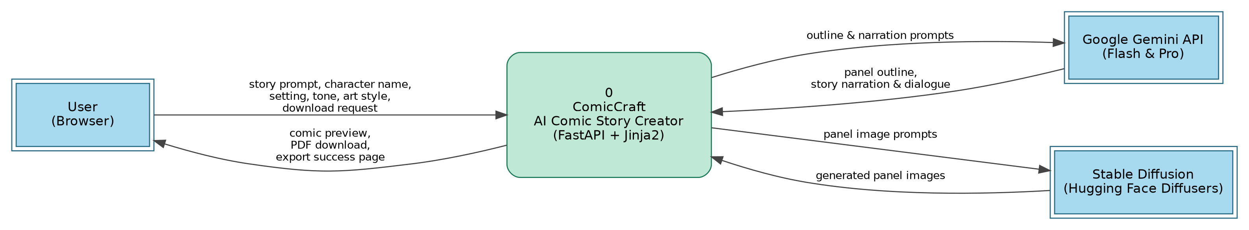
- User (Browser): sends the story prompt, character name, setting, tone, art style and download request; receives the comic preview, PDF and export success page.
- Google Gemini API: receives outline and narration prompts; returns the panel outline and the story narration with dialogue.
- Stable Diffusion (Diffusers): receives panel image prompts; returns the generated panel images.
DFD Level 1: ComicCraft
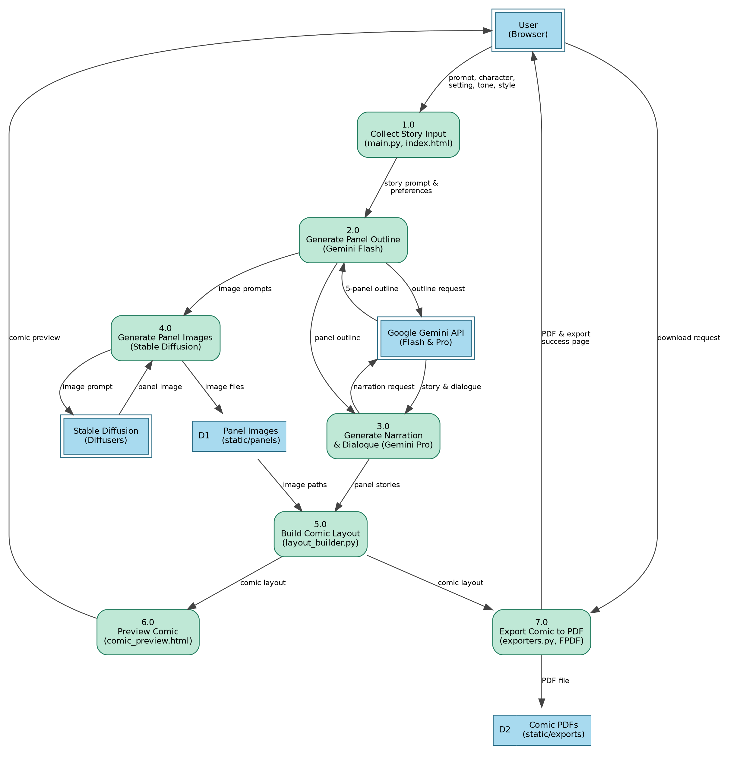
- User opens the ComicCraft web page and fills the form: story prompt, character name, setting, tone and art style.
- FastAPI (main.py, routes.py) receives the form data through a POST request and renders pages with Jinja2 templates.
- Gemini Flash generates a structured 5-panel outline: panel number, title, scene description and an image prompt.
- Gemini Pro expands the outline into narration and character dialogue for every panel.
- Stable Diffusion (Hugging Face Diffusers) creates a comic-style image for each panel's image prompt. Images are saved in static/panels (D1).
- layout_builder.py matches each image with its panel text and builds the comic layout.
- comic_preview.html shows the comic panel by panel to the user.
- On download, exporters.py compiles the layout into a PDF with FPDF, saves it with a timestamp in static/exports (D2) and redirects to export_success.html.
Data stores
- D1 Panel Images: generated panel images in static/panels.
- D2 Comic PDFs: exported comic PDFs in static/exports.

User Stories
Use the below template to list all the user stories for the product.
User Type | Functional Requirement (Epic) | User Story Number | User Story / Task | Acceptance criteria | Priority | Release
Customer (Mobile user) | Story Input | USN-1 | As a user, I can open the ComicCraft page in my phone browser and see the input form for story prompt, character name, setting, tone and art style. | The form loads and all five fields are usable on a mobile screen | High | Sprint-1
 |  | USN-2 | As a user, I can enter a story prompt describing my comic idea, such as "A brave fox exploring an enchanted forest". | The prompt is submitted to the FastAPI backend | High | Sprint-1
 | Customization | USN-3 | As a user, I can enter the main character's name and the setting (e.g. forest, school, city). | The name and setting appear in the generated outline and story | High | Sprint-1
 |  | USN-4 | As a user, I can choose the story tone (e.g. dramatic, funny) and the art style (e.g. anime, comic book, realistic). | The story mood and the images match the chosen tone and style | Medium | Sprint-1
 | Comic Generation | USN-5 | As a user, I receive a structured 5-panel comic outline generated from my prompt. | Each panel has a number, title, scene description and image prompt | High | Sprint-1
 |  | USN-6 | As a user, I receive narration and character dialogue for every panel. | Each panel has story text and dialogue | High | Sprint-2
 |  | USN-7 | As a user, I receive a comic-style illustration for every panel. | One image per panel is generated and saved | High | Sprint-2
 | Comic Preview | USN-8 | As a user, I can preview the full comic on screen with each panel's image and text. | The preview page shows all panels in order | High | Sprint-2
 | Regeneration | USN-9 | As a user, I can change the tone or art style and submit again to regenerate the whole comic. | A new outline, story and images are produced with the new settings | Medium | Sprint-3
 | Export | USN-10 | As a user, I can download my comic as a PDF containing images and narration. | A PDF with a timestamped file name is downloaded | High | Sprint-3
 |  | USN-11 | As a user, I am taken to an export success page after downloading. | The success page confirms the export | Medium | Sprint-3
Customer (Web user) | Story Input & Preview | USN-12 | As a web user, I can create, preview and export a comic using the website on my desktop browser. | The full flow from input form to PDF export works on desktop | High | Sprint-2
 | API Access | USN-13 | As a web user, I can send a JSON request to the API endpoint and receive a generated comic. | The API returns the outline, story and image paths in JSON | Medium | Sprint-3
Customer Care Executive | Support | USN-14 | As a customer care executive, I can use the image test route to check that panel images generate, so I can help users who report missing images. | The test route returns a generated image | Medium | Sprint-3
 |  | USN-15 | As a customer care executive, I can find a user's exported PDF by its timestamped name to help a user who lost a download. | The correct PDF is found in the exports folder | Low | Sprint-3
Administrator | Configuration | USN-16 | As an administrator, I can configure the Gemini API key and the models (Gemini Flash, Gemini Pro, Stable Diffusion v1-5). | The app connects to all three models | High | Sprint-1
 | Deployment | USN-17 | As an administrator, I can run the app locally with Uvicorn and test it at the home page and the /docs page. | The app starts and both pages open | High | Sprint-1
 | Maintenance | USN-18 | As an administrator, I can review and clear generated files in static/panels and static/exports. | Old images and PDFs can be removed to free space | Low | Sprint-3

3.4 Technology stack
Table-1: Components & Technologies
S.No | Component | Description | Technology
1 | User Interface | Provides the interface through which users enter their story prompt, character name, setting, tone, and preferred art style and view the generated comic. | HTML, CSS, Jinja2
2 | Application Logic-1 | Handles user requests, form processing, routing, validation, and coordination of the comic-generation workflow. | Python, FastAPI
3 | Application Logic-2 | Generates a structured panel-by-panel comic outline from the user's story prompt. | Google Gemini Flash
4 | Application Logic-3 | Converts the generated comic outline into detailed narration and character dialogues. | Google Gemini Pro
5 | Application Logic-4 | Generates comic-style illustrations based on the image-generation prompts produced for each panel. | Stable Diffusion, Hugging Face Diffusers
6 | Database | The current project does not specify a persistent database. User inputs and generated comic data are processed during the generation workflow. | Not specified / In-memory processing
7 | Cloud Database | No cloud database is specified in the current ComicCraft implementation. | Not specified
8 | File Storage | Stores generated panel images and exported PDF files. Generated images are stored in the static/panels directory and PDFs in static/exports. | Local File System
9 | External API-1 | Provides AI-powered generation of structured comic outlines from user prompts. | Google Gemini API
10 | External API-2 | Provides AI-powered generation of detailed comic narration and character dialogues. | Google Gemini API
11 | Machine Learning Model-1 | Generates structured comic panel outlines quickly based on user requirements. | Gemini Flash
12 | Machine Learning Model-2 | Generates detailed creative narration and character dialogues. | Gemini Pro
13 | Machine Learning Model-3 | Generates comic-style visual illustrations from image prompts. | Stable Diffusion v1.5
14 | PDF Generation | Combines comic images, panel titles, narration, and other content into a downloadable PDF. | FPDF
15 | Infrastructure (Server / Cloud) | Runs the FastAPI application and provides access to the web interface and API endpoints. | Uvicorn / FastAPI Local Server

Table-2: Application Characteristics
S.No | Characteristics | Description | Technology
1 | Open-Source Frameworks | The application uses open-source technologies for backend development, frontend templating, image generation, and PDF generation. | FastAPI, Python, Jinja2, Hugging Face Diffusers, Stable Diffusion, FPDF
2 | Security | Sensitive AI credentials such as Gemini API keys and Hugging Face tokens are stored using environment variables instead of directly embedding them in application code. User input is processed through FastAPI form parameters and Pydantic validation for API requests. | Environment Variables, FastAPI Validation, Pydantic
3 | Scalable Architecture | The application follows a modular architecture where frontend templates, FastAPI routes, AI generation modules, image generation, layout processing, and PDF export are separated. This allows individual components to be enhanced or replaced independently. | FastAPI, Python Modules, Jinja2
4 | Availability | The application can be accessed through the FastAPI server when it is running. Uvicorn is used as the ASGI server, and FastAPI provides API endpoints that can be accessed through the application and API documentation. | FastAPI, Uvicorn
5 | Performance | Gemini Flash is selected for fast structured comic-outline generation, while Gemini Pro is used for detailed creative content. The image-generation workflow uses Stable Diffusion, and the generated results are processed panel-by-panel. | Gemini Flash, Gemini Pro, Stable Diffusion, FastAPI

PROJECT DESIGN
4.1 Problem -solution fit:
1. CUSTOMER SEGMENT(S)  Primary users are non-artists, storytellers, hobbyists and casual users who want to turn a simple story idea into a complete comic. Students and creative users can also use the tool for personalized comic creation. | 6. CUSTOMER CONSTRAINTS  Users may lack drawing or comic-design skills and may not have enough time to write, illustrate and arrange panels manually. They also depend on AI model/API availability and may need to review generated content for accuracy and consistency. | 5. AVAILABLE SOLUTIONS  Current alternatives include manually writing and drawing comics, using separate story-writing and image-generation tools, or using conventional comic-creation software. These approaches may require more time or multiple tools.
2. JOBS-TO-BE-DONE / PROBLEMS  Users want to transform a simple prompt into a complete comic without needing professional writing or drawing skills. They need storyline, narration, character dialogue, illustrations, panel organization and a shareable PDF. | 9. PROBLEM ROOT CAUSE  The main difficulty is that comic creation combines several creative tasks: story planning, dialogue writing, scene description, illustration and layout. Doing all these tasks manually requires time, creativity and technical/artistic skills. | 7. BEHAVIOUR  Users describe their story idea and customize the character, setting, tone and art style. They review the generated comic panel-by-panel and can download the final comic as a PDF for saving, sharing or offline viewing.
3. TRIGGERS  • Having a story idea but not knowing how to turn it into a comic.  • Wanting a personalized comic with a chosen character, setting, tone and art style.  • Wanting a quick visual story that can be downloaded and shared.  4. EMOTIONS: BEFORE / AFTER  Before: difficulty, uncertainty and frustration about creating a complete comic.  After: excitement, satisfaction and confidence after seeing the idea converted into a personalized comic. | 10. YOUR SOLUTION  ComicCraft is a web-based AI comic creator. Users enter a story prompt, character name, setting, tone and art style. Gemini Flash creates a 5-panel outline, Gemini Pro creates narration and dialogue, Stable Diffusion creates illustrations, and the system builds and exports the comic as a PDF. | 8. CHANNELS OF BEHAVIOUR  ONLINE  • Web application / browser interface  • FastAPI API endpoints  • Generated comic preview page  • PDF download  OFFLINE / OUTPUT  • Downloaded PDF comic  • Saved comic for sharing, printing or offline viewing

4.2 Proposed solution
S.No. | Parameter | Description
1. | Problem Statement (Problem to be solved) | Creating a complete comic requires storytelling, dialogue writing, illustration, and panel designing skills. This process is time-consuming and difficult for people without artistic skills.
2. | Idea / Solution description | ComicCraft is an AI-based web application that converts a user's story prompt into a complete comic. It uses Gemini AI to generate the storyline, narration and dialogues, and Stable Diffusion to generate comic illustrations. Users can preview the comic and download it as a PDF.
3. | Novelty / Uniqueness | ComicCraft combines AI story generation, dialogue generation, image generation, comic panel organization and PDF export in a single application. Users can customize the character, setting, tone and art style according to their creative idea.
4. | Social Impact / Customer Satisfaction | ComicCraft makes comic creation accessible to students, storytellers, hobbyists and non-artists. It reduces the effort required for creating stories and illustrations and allows users to quickly turn their ideas into visual content.
5. | Business Model (Revenue Model) | The application can use a freemium model, where basic comic generation is free and advanced features can be offered through a paid plan. Revenue can also be generated through premium art styles, additional comic generations, advanced customization and downloadable premium formats.
6. | Scalability of the Solution | ComicCraft can be expanded to support more users, additional AI models, more art styles, longer multi-page stories, user profiles, comic libraries and cloud deployment. Its modular architecture supports future enhancements.

4.3 Solution architecture
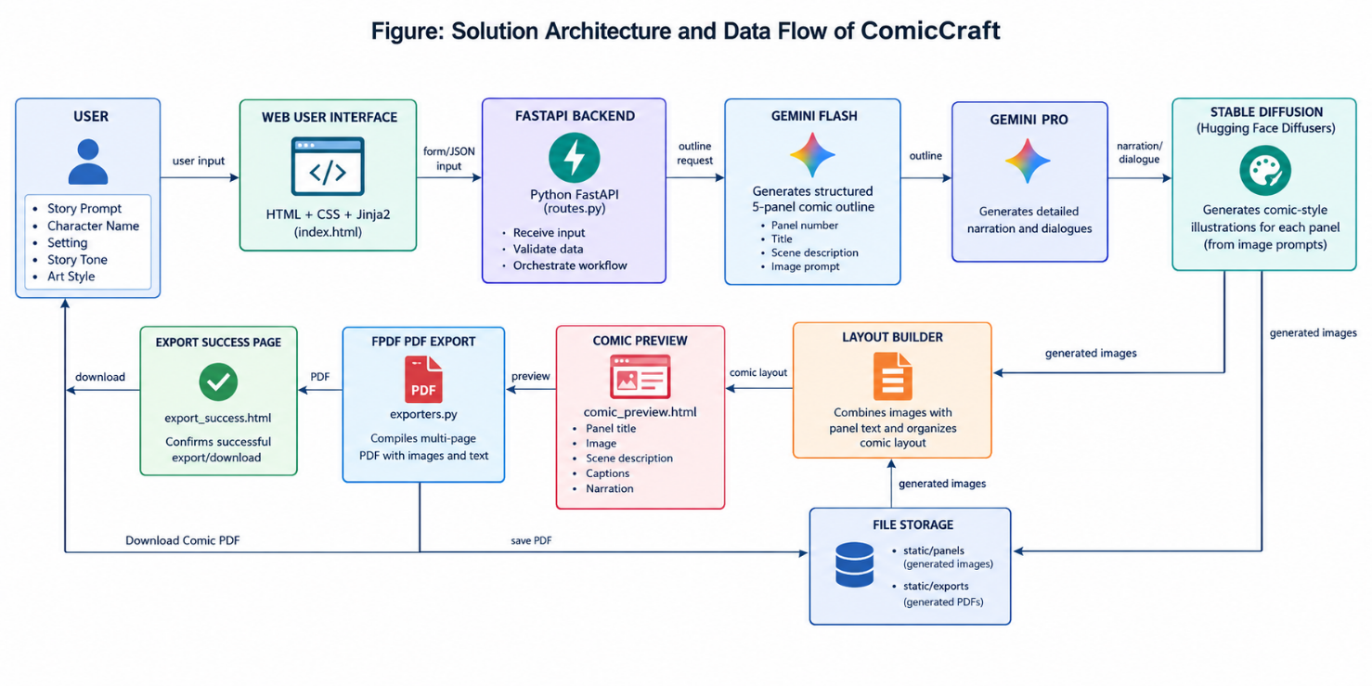

PROJECT PLANNING AND SCHEDULING
Product Backlog, Sprint Schedule, and Estimation (4 Marks)
Sprint | Functional Requirement (Epic) | User Story Number | User Story / Task | Story Points | Priority | Team Members
Sprint-1 | User Input & Story Creation | USN-1 | As a user, I can enter a story prompt, character name, setting, tone, and art style. | 2 | High | Subasri, Yuvasri
Sprint-1 | AI Story Generation | USN-2 | As a user, I can generate a structured comic outline using AI. | 2 | High | Vishrutha, Kirshnapriya
Sprint-1 | AI Story Generation | USN-3 | As a user, I can generate narration and character dialogues for the comic panels. | 2 | High | Yuvasri, Dharshini
Sprint-1 | Image Generation | USN-4 | As a user, I can generate comic illustrations for the generated panels. | 2 | High | Vishrutha, Subasri
Sprint-1 | Frontend | USN-5 | As a user, I can access a simple web interface to create a comic. | 2 | Medium | Dharshini, Kirshnapriya
Sprint-2 | Comic Preview | USN-6 | As a user, I can view the generated comic panels with images, captions, and narration. | 2 | High | Subasri, Dharshini
Sprint-2 | PDF Export | USN-7 | As a user, I can download the generated comic as a PDF. | 2 | High | Yuvasri, Vishrutha
Sprint-2 | Backend Integration | USN-8 | As a user, I can generate a comic through the integrated FastAPI backend. | 2 | High | Kirshnapriya, Subasri
Sprint-2 | Testing | USN-9 | As a project team, we can test comic generation, preview, image generation, and PDF export. | 2 | Medium | All Members
Sprint-2 | Documentation | USN-10 | As a project team, we can document the project workflow, results, and future scope. | 2 | Medium | All Members

Project Tracker, Velocity & Burndown Chart (4 Marks)
Sprint | Total Story Points | Duration | Sprint Start Date | Sprint End Date (Planned) | Story Points Completed | Sprint Release Date (Actual)
Sprint-1 | 10 | 3 Days | 29 Sep 2026 | 01 Oct 2026 | 10 | 01 Oct 2026
Sprint-2 | 10 | 2 Days | 02 Oct 2026 | 03 Oct 2026 | 10 | 03 Oct 2026

Velocity:
Total story points = 20. Total project duration = 5 days. Average velocity = 20 ÷ 5 = 4 story points/day.
Burndown Chart Data
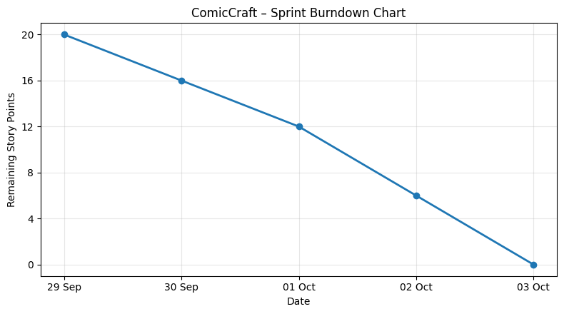

Team Responsibilities
Team Member | Planned Responsibility
Yuvasri | Story generation, backend integration and testing
Vishrutha | AI/image generation and PDF export
Krishnapriya | Frontend, FastAPI integration and documentation
Dharshini | Frontend, comic preview and testing
Subasri | Project coordination, user input module and final integration

FUNCTIONAL AND PERFORMANCE TESTING
The application was tested locally to verify the complete comic generation workflow.

6.1 Functional Testing
Test Case | Input/Action | Output/Expected Result
TC01 | Open homepage | Homepage loads successfully
TC02 | Enter story prompt | Prompt accepted
TC03 | Enter character name | Character information accepted
TC04 | Select setting | Selected setting accepted
TC05 | Select story tone | Tone accepted
TC06 | Select art style | Selected style accepted
TC07 | Submit form | Comic generation begins
TC08 | Generate outline | Five panel outline generated
TC09 | Generate story | Narration and dialogue generated
TC10 | Generate images | Images generated for panels
TC11 | View preview | Comic displayed panel-by-panel
TC12 | Download PDF | PDF generated and downloaded
TC13 | Open API docs | FastAPI documentation accessible

Performance Observation
The source document confirms local deployment and testing using Uvicorn and the FastAPI application. It specifies that the complete workflow includes AI text generation, image creation, layout building and PDF export. However, the source does not provide
numerical measurements such as response time, throughput, CPU usage, RAM usage, or image-generation time, so these values should be measured during your actual testing rather than invented.

RESULTS
  - Output Screenshots
The following screenshots can be included in the final report:
Screenshot 1 – ComicCraft Homepage
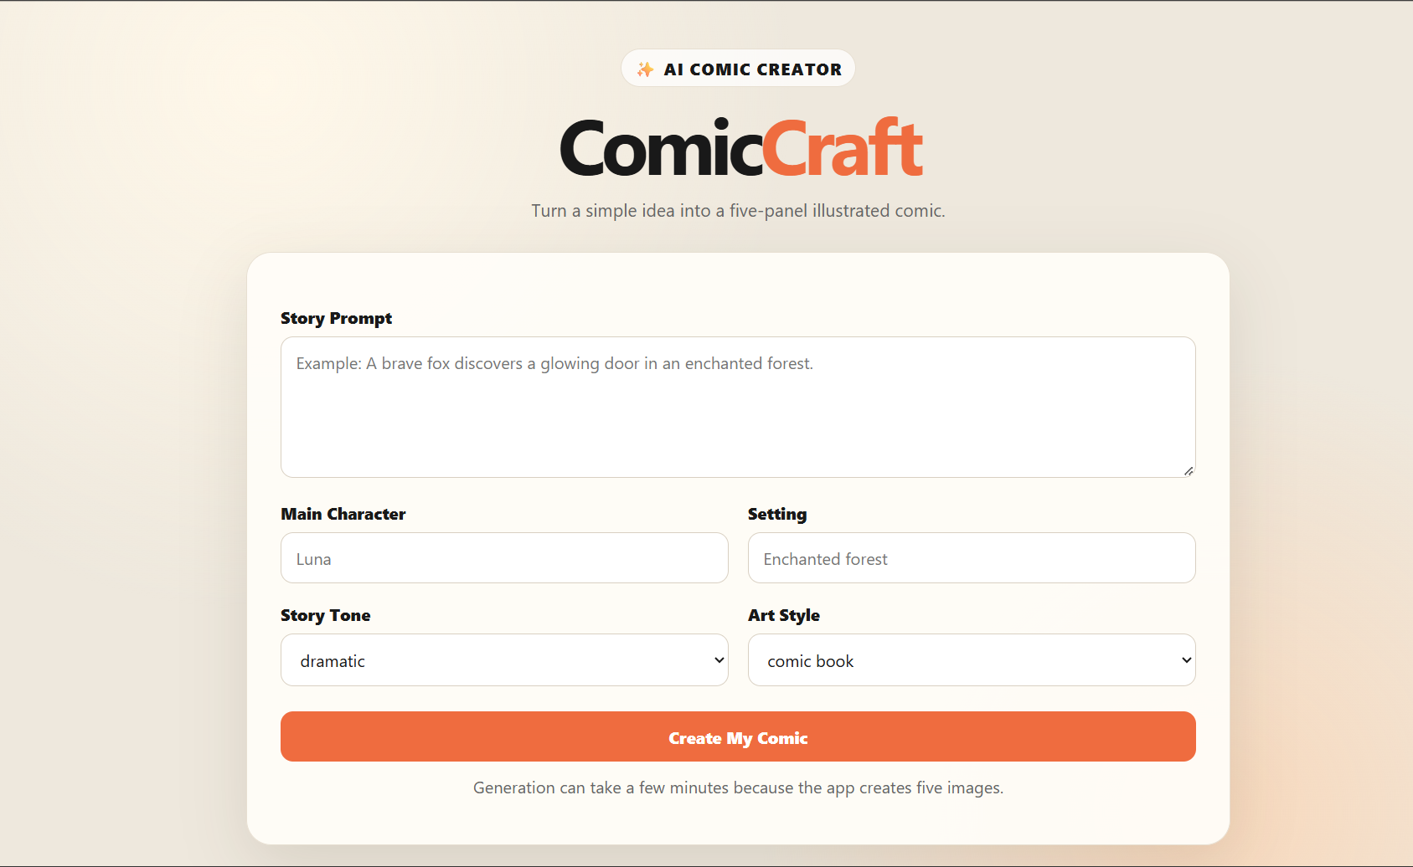
Screenshot 2 – Comic Preview Page
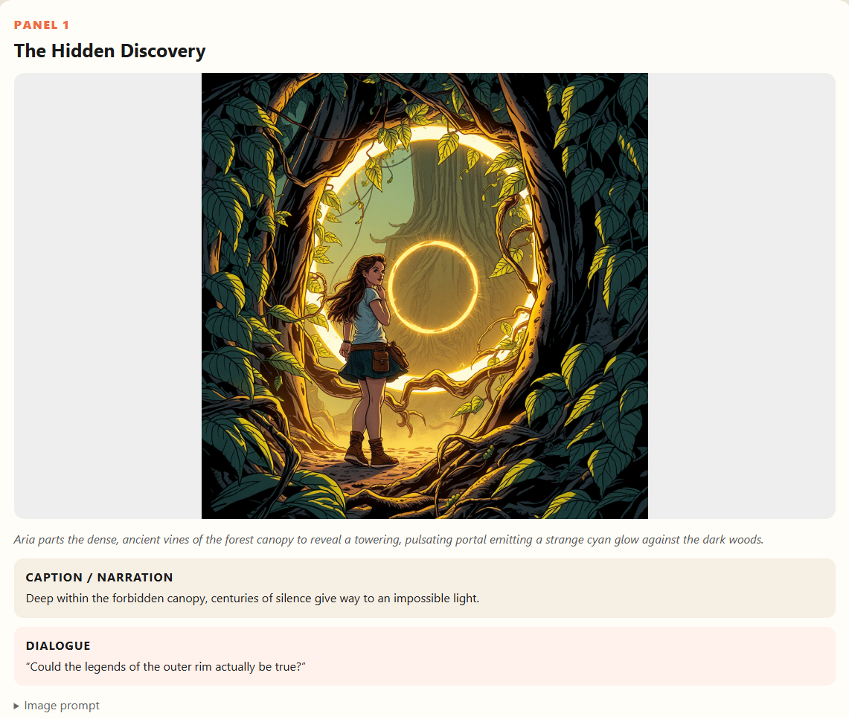
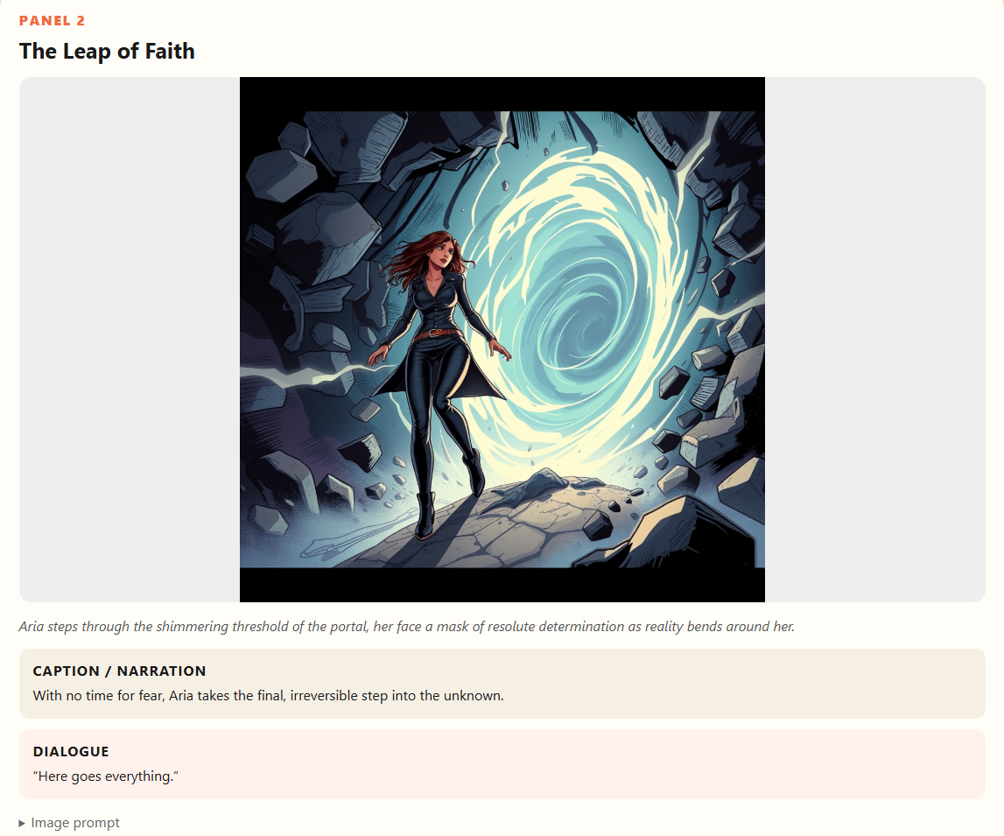
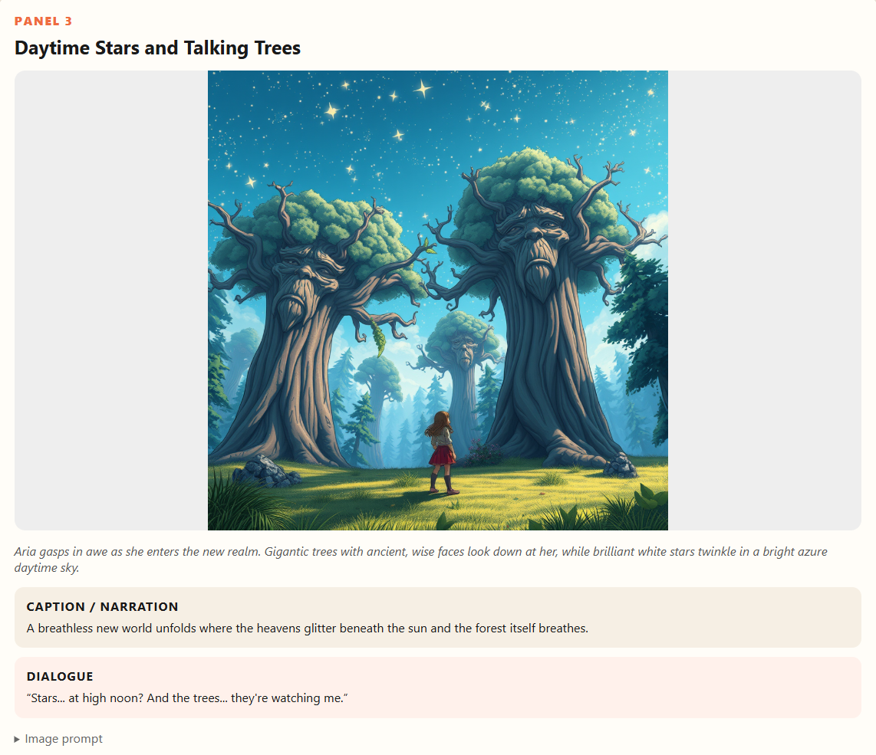

Screenshot 3 – PDF Download
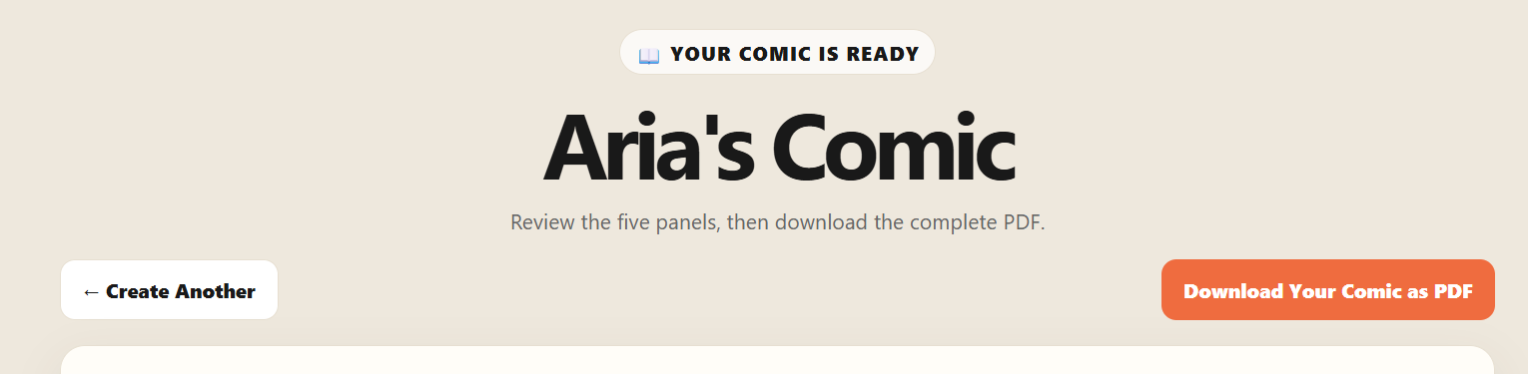

Screenshot 4 – Export Success Page
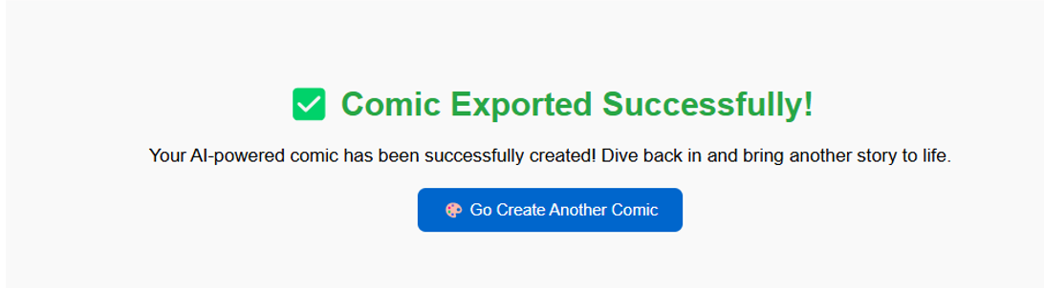

ADVANTAGES & DISADVANTAGES
8.1 Advantages:
- Reduces the time required to create comics.
- Generates both stories and illustrations automatically.
- Allows users to customize their comics.
- Does not require professional drawing skills.
- Provides a simple web interface.
- Supports multiple art styles and story tones.
- Generates panel-by-panel comic content.
- Provides PDF export functionality.
- Combines text and image generation in one workflow
- Modular architecture makes future improvements easier.
8.2 Disadvantages:
- AI-generated content may not always match the user's exact expectations.
- Image generation can require significant computational resources.
- AI model/API availability may affect the application.
- API keys and external AI services must be configured correctly.
- The current version does not include user account management.
- The current version focuses on single comic generation.
- Generated content may require user review before final use.

CONCLUSION
ComicCraft successfully demonstrates the use of generative AI for automated comic creation. The system combines Gemini Flash and Gemini Pro for story generation, narration and dialogue with Stable Diffusion for comic-style image generation.The application provides an end-to-end workflow beginning with a simple user prompt and ending with a complete downloadable comic. Users can customize the character, setting, tone and art style, preview the generated comic, and export it as a PDF.
FUTURE SCOPE
The following enhancements can be considered for future development:
- User Authentication
  - Add login and registration functionality.
- User Profiles
  - Allow users to maintain personal comic collections.
- Comic Library
  - Store previously generated comics for later access.
- Multi-Page Story Arcs
  - Support longer stories beyond the current five-panel structure.
- Character Consistency

  - Improve consistency of characters across different panels.
- More Art Styles
  - Add additional image-generation styles.
- Comic Editing
  - Allow users to edit generated narration, dialogue and images before export.
- Cloud Deployment
  - Deploy the application to a cloud platform for public access.
- Mobile-Friendly Interface
  - Improve the interface for smartphones and tablets.
10.Advanced Customization
- Allow users to control panel layouts, image composition, dialogue placement and comic dimension
APPENDIX
Demo link: https://drive.google.com/file/d/1pshvwPKZOItr0PAkqz2ddPjLTGySYsFE/view?usp=sharing

